Step Up for Health!
Personal Log
The Log is only a tool to help you keep track of your steps. You will submit your steps in the provided link on the LifeBeats webpage each new week.
 |  |  | Week 1 - Get Moving!
 | Monday | Tuesday | Wednesday | Thursday | Friday | Saturday | Sunday
# of STEPS:
 |  |  | Weekly Total:
 |  |  | Week 2 - Keep it Up!
 | Monday | Tuesday | Wednesday | Thursday | Friday | Saturday | Sunday
# of STEPS:
 |  |  | Weekly Total:
 |  |  | Week 3- Pick Up the Pace!
 | Monday | Tuesday | Wednesday | Thursday | Friday | Saturday | Sunday
# of STEPS:
 |  |  | Weekly Total:

 |  |  | Week 4- Almost Done!
 | Monday | Tuesday | Wednesday | Thursday | Friday | Saturday | Sunday
# of STEPS:
 |  | 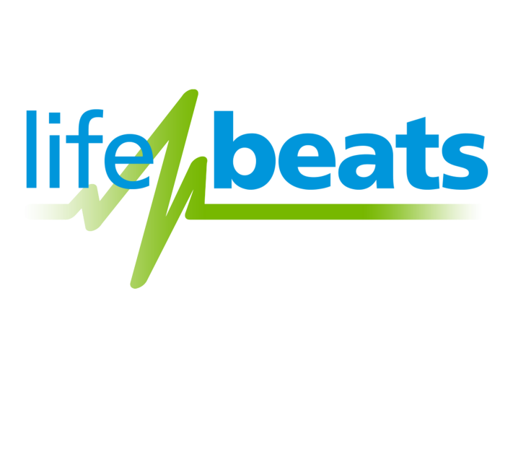 | Weekly Total:

